BMSim

IoT Fundamentals Course

Amirreza Hosseini 9820363

**Third scenario:** A network with friends and low-power nodes.

we need to design a network with the same properties as the past ones. Here we have a friend node, a relay, and a friend node, and for each of them a low-power node. To achieve this, first, we need to modify the choice_feature.py file. Before this, we first need to know about the topology of our network for preventing any disconnection from happening in it. We experiment with this with a grid and a random network.

The important thing is that the distance between a friend and a low-power node should not be more than one hop.

    #our new configuration

    nodes[0].feature = 4 #low power

    nodes[6].feature = 4 #low power

    nodes[1].feature = 5    #friend and relay

    nodes[5].feature = 6    #friend

    #friendship

    nodes[0].friend_Id = 1

    nodes[6].friend_Id = 5

    nodes[1].LOW_POWER_ID = 0

    nodes[5].LOW_POWER_ID = 6

We want to delete the id of low-power nodes from heartbeat messages to prevent them to receive these messages. We will achieve simplicity for our network by doing this task because the friend of their nodes will receive them anyway. (Modification of event_driven.py file in HEARTBEAT_EVENT_Adv37 section)

destination.remove(nodes[1].LOW_POWER_ID)

destination.remove(nodes[5].LOW_POWER_ID)

One other thing is to set the low-power nodes as the destination of some packet generator nodes. To do so, we need to modify the event_driven.py file in GENERATION_EVENT_Adv37

#destination assignment for the generative nodes

            if i_node == 23:

                destination1=[0]

            if i_node == 17:

                destination1=[6]

Our focus in this scenario is on the energy consumption of the network because we have low-energy nodes here.

The default algorithm for a grid network:

a) the topology of our grid network same as this:

Graph with 49 nodes and 84 edges

initial [[776, 1], [12, 6], [16, 6], [12, 6], [13, 6], [25, 6], [814, 1], [2, 6], [9, 6], [7, 6], [9, 6], [26, 6], [17, 6], [4, 6], [16, 6], [11, 6], [17, 6], [20, 6], [2, 6], [16, 6], [15, 6], [0, 6], [28, 6], [4, 6], [27, 6], [14, 6], [15, 6], [7, 6], [9, 6], [13, 6], [13, 6], [13, 6], [29, 6], [29, 6], [30, 6], [9, 6], [17, 6], [23, 6], [10, 6], [18, 6], [13, 6], [1, 6], [10, 6], [30, 6], [13, 6], [26, 6], [16, 6], [16, 6], [16, 6]]

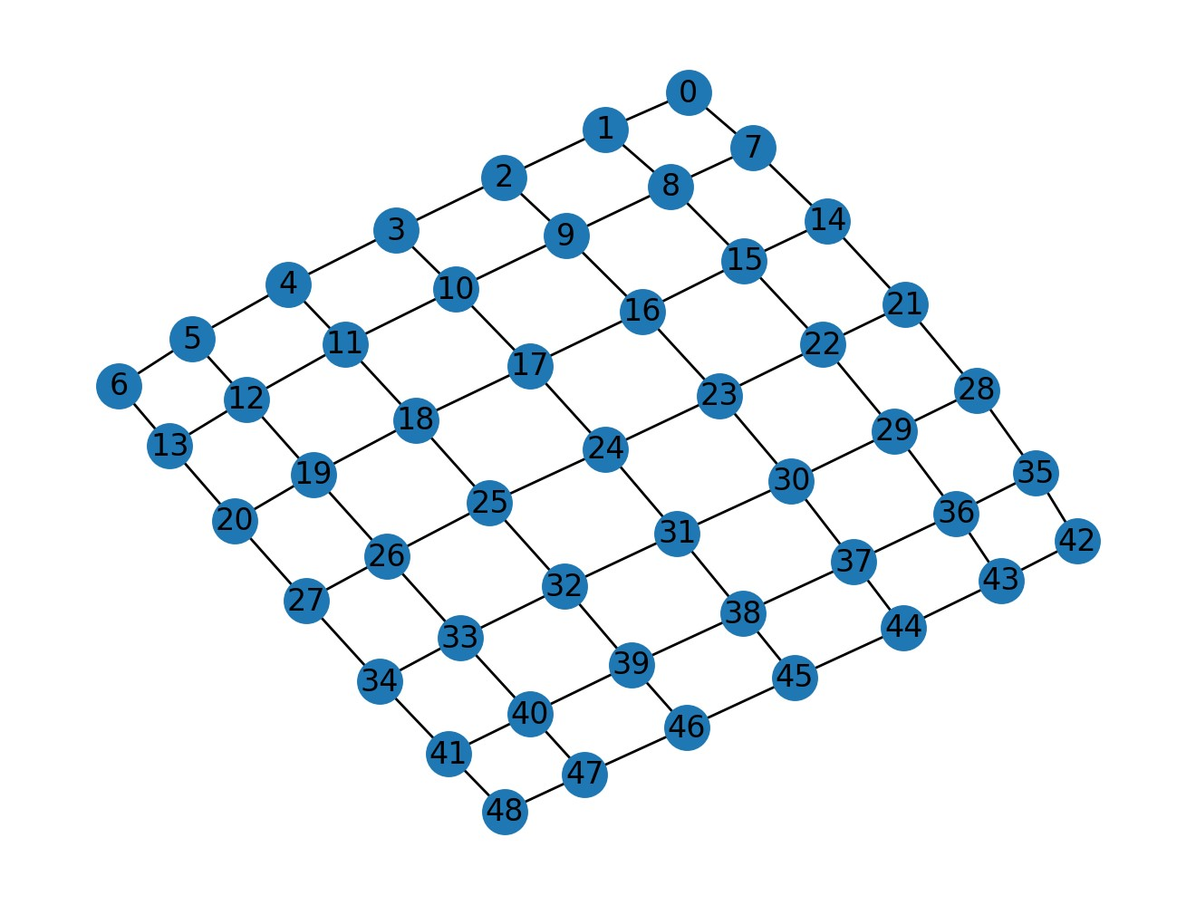

b) here is our configuration for the generator nodes:

#destination assignment for the generative nodes

            if i_node == 23:

                destination1=[0]

            if i_node == 17:

                destination1=[6]

we want to check if the generated packets from node 23 will receive to the low-power node 0 or not:

In 23.log we have:

(generate) 23 6 [0] 1

(generate) 23 1006.05 [0] 2

In 30.log we have:

(relay) 23 23 6.0 1 6 127 1

(advertise) 30 31.2 23 1

In 29.log we have:

(relay) 30 23 31.2 1 6 126 1

(advertise) 29 31.4 23 1

In 22.log we have:

(relay) 29 23 31.6 1 6 125 1

(advertise) 22 31.8 23 1

In 21.log we have:

(relay) 22 23 32.0 1 6 124 1

(advertise) 21 32.2 23 1

In 14.log we have:

(relay) 21 23 32.2 1 6 123 1

(advertise) 14 32.4 23 1

In 7.log we have:

(relay) 14 23 32.4 1 6 122 1

(advertise) 7 35.2 23 1

In 8.log we have:

(relay) 7 23 35.4 1 6 121 1

(advertise) 8 40.0 23 1

In 1.log we have:

(relay) 8 23 40.01 1 6 120 1

here we have arrived packets at 0.log file from node 23:

(main)    23    1    6    0    6745.03

(main)    23    3    2006.2    0    6850.84

(main)    23    4    3006.4    0    6976.05

(main)    23    5    4006.99    0    7035.06

So, there is a path from node 23 to node 0. And the system works well.

We do the same thing with node 17 as a generative and node 6 as a low-power node.

In 10.log we have:

(relay) 17 17 1680.62 1 1680.02 127 1

(advertise) 10 1697.82 17 1

In 3.log we have:

(relay) 10 17 1698.82 1 1680.02 126 1

(advertise) 3 1700.22 17 1

In 4.log we have:

(relay) 3 17 1701.2 1 1680.02 125 2

(advertise) 4 1724.82 17 1

here we have arrived packets at 6.log file from node 17:

(main)    17    1    1680.02    6    8004.25

(main)    17    2    2680.19    6    8119.66

(main)    17    3    3680.39    6    8262.88

So, there is a path from node 17 to node 6. And the system works well.

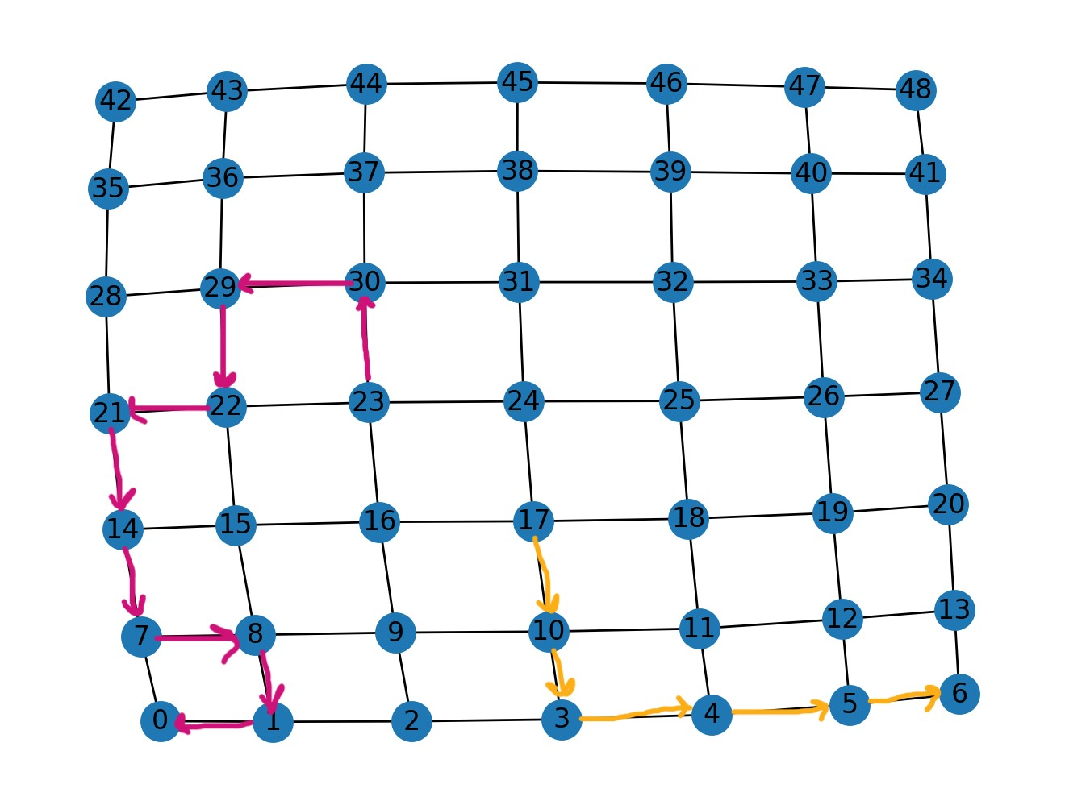

c) The performance metrics that are calculated for this scenario are these:

nodes PDR  [66.66666666666666, 100.0, 96.55172413793103, 100.0, 100.0, 100.0, 90.0, 96.55172413793103, 96.55172413793103, 100.0, 100.0, 100.0, 100.0, 96.55172413793103, 100.0, 100.0, 96.55172413793103, 10.344827586206897, 100.0, 100.0, 100.0, 100.0, 100.0, 24.137931034482758, 0, 93.10344827586206, 100.0, 100.0, 93.10344827586206, 100.0, 100.0, 100.0, 100.0, 100.0, 100.0, 100.0, 100.0, 100.0, 96.55172413793103, 100.0, 100.0, 100.0, 100.0, 93.10344827586206, 100.0, 100.0, 96.55172413793103, 93.10344827586206, 100.0]

average PDR in the network [94.5713601532567]

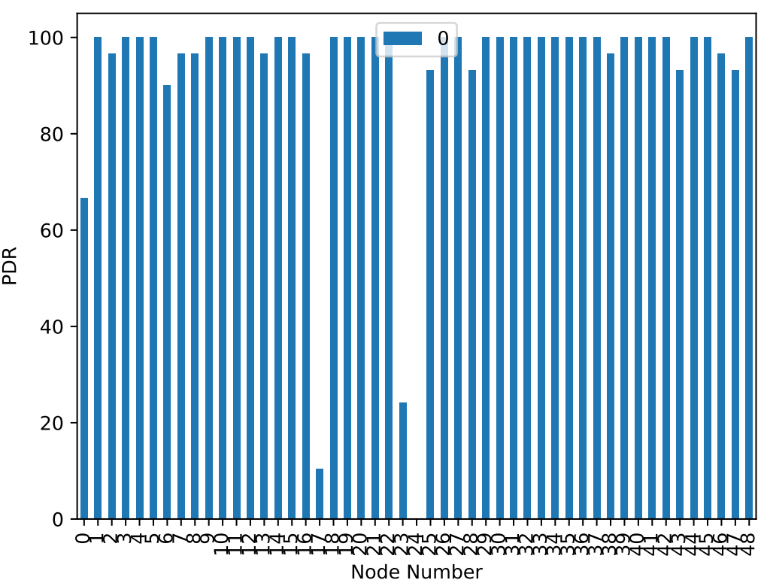

average latency in each node [67.93900000000001, 40.1720689655171, 56.57214285714283, 45.68206896551713, 19.474827586207123, 41.32827586206911, 53.8048148148146, 41.32928571428568, 43.63071428571413, 44.76172413793064, 11.677586206896656, 27.249999999999936, 12.924482758621009, 19.291785714285407, 20.653793103448216, 12.12275862068941, 11.663571428571256, 5001.866666666667, 16.26241379310364, 26.724137931034875, 47.63931034482766, 13.178620689654924, 14.804827586206603, 2671.184285714286, 0, 2.026296296296508, 16.866206896551816, 15.981379310344852, 26.37666666666649, 27.581379310345152, 14.713793103448552, 1.2558620689655355, 17.4541379310344, 31.728275862069072, 44.26793103448282, 30.836896551723918, 37.09206896551721, 23.55689655172455, 33.255714285714184, 16.33103448275879, 23.06379310344861, 32.80896551724134, 22.27241379310332, 32.80629629629638, 16.480344827586123, 17.35862068965513, 32.368571428571215, 22.94629629629644, 47.31896551724123]

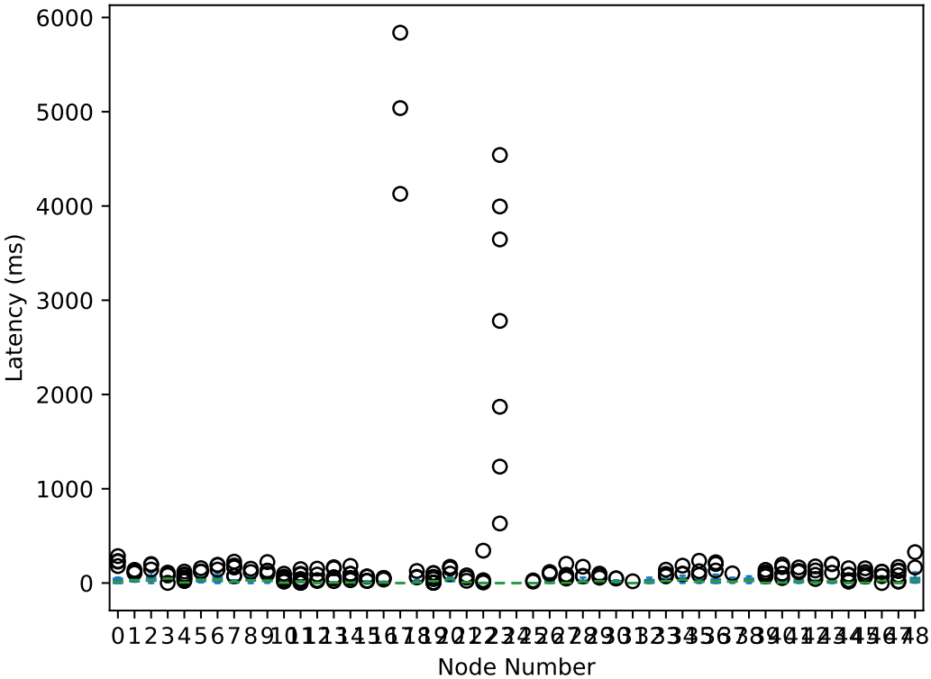

average burst packet loss in each node [[0.5, 0, 0.03571428571428571, 0, 0, 0, 0.1111111111111111, 0.03571428571428571, 0.03571428571428571, 0, 0, 0, 0, 0.03571428571428571, 0, 0, 0.03571428571428571, 0, 0, 0, 0, 0, 0, 0, 0, 0.07407407407407407, 0, 0, 0.07407407407407407, 0, 0, 0, 0, 0, 0, 0, 0, 0, 0.03571428571428571, 0, 0, 0, 0, 0.07407407407407407, 0, 0, 0, 0.07407407407407407, 0]]

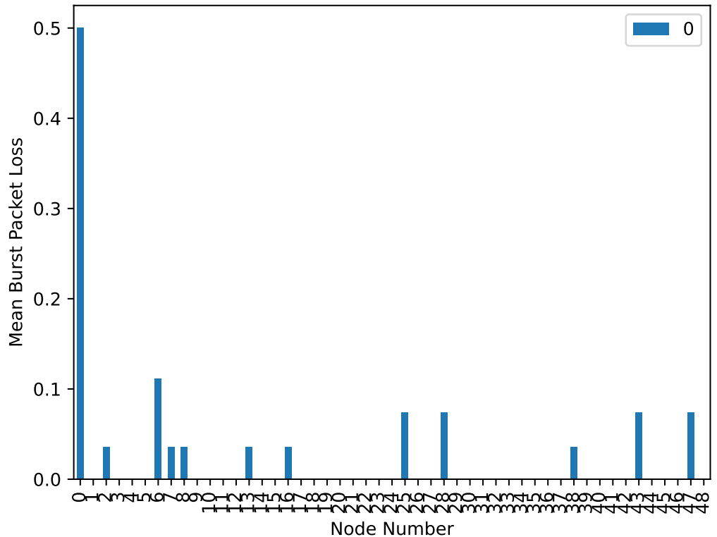

scanning energy in each node [86.6192400000126, 1213.328220002952, 1218.824280002972, 1213.9870800029544, 1220.3171400029773, 1247.7891000030775, 42.2671200000039, 1213.2364800029516, 1215.0212400029582, 1204.0791600029183, 1213.9036800029542, 1200.7515000029061, 1213.9787400029543, 1213.3532400029521, 1219.383060002974, 1204.2126000029189, 1207.4485200029308, 1193.1621000028786, 1206.2559000029264, 1203.145080002915, 1218.1070400029694, 1213.8286200029538, 1214.6292600029567, 1194.1879200028823, 1249.5238200030838, 1191.4941000028725, 1213.2531600029517, 1212.6777000029497, 1218.557400002971, 1202.7614400029136, 1205.2384200029226, 1191.936120002874, 1199.867460002903, 1197.9492600028962, 1217.181300002966, 1211.1264600029442, 1212.7611000029501, 1201.535460002909, 1209.5668800029384, 1196.0811000028893, 1214.1955800029552, 1213.027980002951, 1219.8334200029758, 1210.601040002942, 1214.395740002956, 1207.2316800029298, 1217.2563600029664, 1210.884600002943, 1221.3513000029811]

switching energy in each node [0.1844640000000002, 2.4210900000000604, 2.0521620000000462, 2.378268000000059, 1.963224000000043, 0.1416420000000002, 0.14493600000000023, 2.4540300000000617, 2.3189760000000565, 3.037068000000041, 2.391444000000059, 3.201768000000016, 2.3650920000000584, 2.440854000000061, 2.015928000000045, 3.0173040000000437, 2.790018000000074, 3.7123379999999386, 2.9086020000000605, 3.0733020000000355, 2.1015720000000484, 2.4210900000000604, 2.292624000000055, 3.689279999999942, 0.023057999999999995, 3.8375099999999196, 2.4177960000000605, 2.4770880000000624, 2.0883960000000474, 3.1062420000000306, 2.9448360000000546, 3.8111579999999234, 3.2511780000000083, 3.3763499999999893, 2.1213360000000487, 2.572614000000066, 2.444148000000061, 3.1589460000000225, 2.67143400000007, 3.5278739999999664, 2.361798000000058, 2.470500000000062, 2.0027520000000445, 2.549556000000065, 2.3486220000000575, 2.780136000000074, 2.1542760000000505, 2.569320000000066, 1.88746200000004]

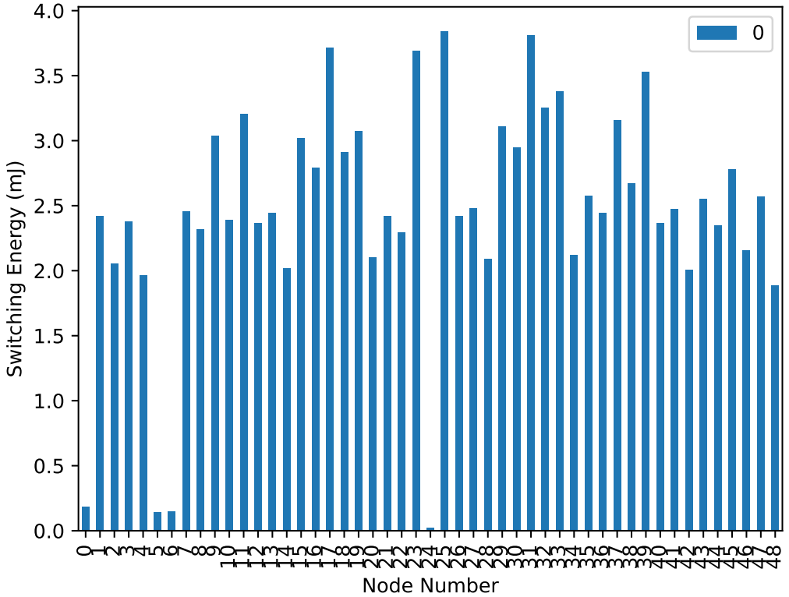

transmitting energy in each node [1.2946752000000015, 16.992611999999124, 14.403261599999349, 16.692062399999152, 13.779043199999403, 0.9941255999999994, 1.0172447999999996, 17.223803999999106, 16.275916799999187, 21.31590239999875, 16.78453919999914, 22.47186239999865, 16.59958559999916, 17.131327199999113, 14.14895039999937, 21.17718719999876, 19.581962399998897, 26.055338399998373, 20.414253599998826, 21.570213599998727, 14.750049599999318, 16.992611999999124, 16.0909631999992, 25.893503999998348, 0.16183440000000002, 26.933867999998625, 16.969492799999127, 17.38563839999909, 14.657572799999327, 21.801405599998706, 20.668564799998805, 26.748914399998572, 22.818650399998617, 23.697179999998543, 14.888764799999306, 18.05609519999903, 17.15444639999911, 22.171312799998674, 18.74967119999897, 24.76066319999845, 16.57646639999916, 17.33939999999909, 14.056473599999379, 17.894260799999046, 16.483989599999166, 19.512604799998908, 15.119956799999287, 18.032975999999035, 13.24730159999945]

sleeping energy in each node [1.2186, 0.0, 0.0, 0.0, 0.0, -0.0, 1.2654, 0.0, 0.0, 0.0, 0.0, 0.0, 0.0, 0.0, 0.0, 0.0, 0.0, 0.0, 0.0, 0.0, 0.0, 0.0, 0.0, 0.0, -0.0, 0.0, 0.0, 0.0, 0.0, 0.0, 0.0, 0.0001, 0.0, 0.0, 0.0, 0.0, 0.0, 0.0, 0.0, 0.0, 0.0, 0.0, 0.0, 0.0, 0.0, 0.0, 0.0, 0.0, 0.0]

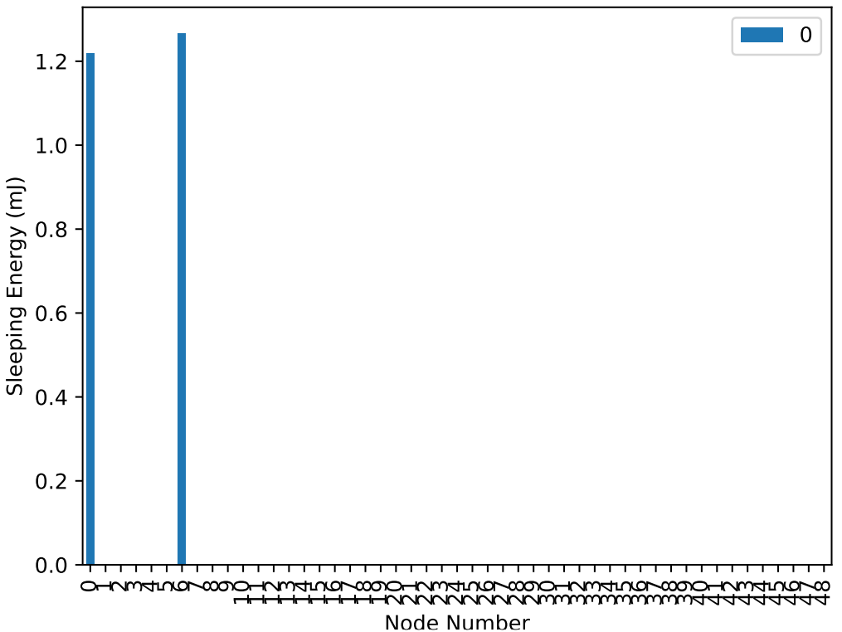

total energy in each node [89.3169792000126, 1232.7419220029512, 1235.2797036029713, 1233.0574104029538, 1236.059407202977, 1248.9248676030775, 44.6947008000039, 1232.9143140029507, 1233.6161328029573, 1228.4321304029172, 1233.0796632029535, 1226.4251304029049, 1232.9434176029536, 1232.9254212029514, 1235.5479384029734, 1228.4070912029176, 1229.8205004029298, 1222.929776402877, 1229.5787556029252, 1227.7885956029136, 1234.9586616029687, 1233.242322002953, 1233.012847202956, 1223.7707040028806, 1249.7087124030838, 1222.265478002871, 1232.640448802951, 1232.540426402949, 1235.3033688029705, 1227.6690876029124, 1228.8518208029216, 1222.4962924028725, 1225.9372884029017, 1225.0227900028947, 1234.1914008029655, 1231.7551692029433, 1232.3596944029493, 1226.8657188029078, 1230.9879852029376, 1224.3696372028876, 1233.1338444029545, 1232.8378800029502, 1235.8926456029753, 1231.0448568029412, 1233.2283516029552, 1229.5244208029287, 1234.5305928029657, 1231.486896002942, 1236.4860636029807]

network energy consumption (mJ) 58020.599263738346

The default algorithm for a random network:

a) the topology of our random network:

Graph with 49 nodes and 181 edges

initial [[20, 6], [198, 1], [69, 1], [4, 6], [21, 6], [7, 6], [0, 6], [2, 6], [29, 6], [17, 6], [20, 6], [24, 6], [10, 6], [23, 6], [14, 6], [18, 6], [1, 6], [18, 6], [19, 6], [22, 6], [13, 6], [15, 6], [29, 6], [23, 6], [17, 6], [30, 6], [27, 6], [5, 6], [11, 6], [12, 6], [24, 6], [13, 6], [28, 6], [18, 6], [29, 6], [2, 6], [2, 6], [17, 6], [13, 6], [3, 6], [18, 6], [22, 6], [24, 6], [6, 6], [24, 6], [21, 6], [4, 6], [6, 6], [11, 6]]

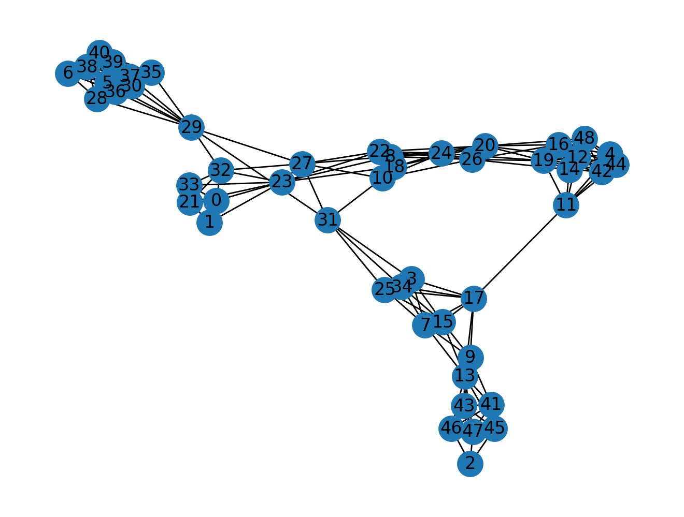

b) here is our configuration for the generator nodes:

#destination assignment for the generative nodes

            if i_node == 28:

                destination1=[1]

            if i_node == 7:

                destination1=[2]

we want to check if the generated packets from node 28 will receive to the low-power node 1 or not:

in 28.log we have:

(generate) 28 3862.27 [1] 3

in 29.log we have:

(relay) 28 28 3863.28 3 3862.27 127 1

(advertise) 29 3875.88 28 3

In 32.log we have:

(relay) 29 28 3876.88 3 3862.27 126 1

(advertise) 32 3895.68 28 3

In 0.log we have:

(relay) 32 28 3895.88 3 3862.27 125 1

here we have arrived packets at 1.log file from node 28:

(main) 28 3 3862.27 1 4337.41

(main)    28    5    5863.17    1    8749.67

(main)    28    6    6863.28    1    8899.28

(main)    28    8    8863.51    1    8979.69

So, there is a path from node 28 to node 1. And the system works well.

We do the same thing with node 7 as a generative and node 2 as a low-power node.

In 7.log we have:

(generate) 7 1867.0 [2] 1

In 13.log we have:

(relay) 7 7 1867.58 1 1867.0 127 1

(advertise) 13 1868.18 7 1

In 43.log we have:

(relay) 13 7 1868.71 1 1867.0 126 1

(advertise) 43 1887.71 7 1

here we have arrived packets at 2.log file from node 7:

(main)    7    1    1867.0    2    6378.63

(main)    7    2    2867.11    2    6692.26

(main)    7    3    3867.28    2    6862.88

(main)    7    4    4867.39    2    7075.7

(main)    7    5    5867.49    2    7395.74

(main)    7    6    6867.59    2    7556.96

So, there is a path from node 7 to node 2. And the system works well.

Here are the traced packets for the above topology:

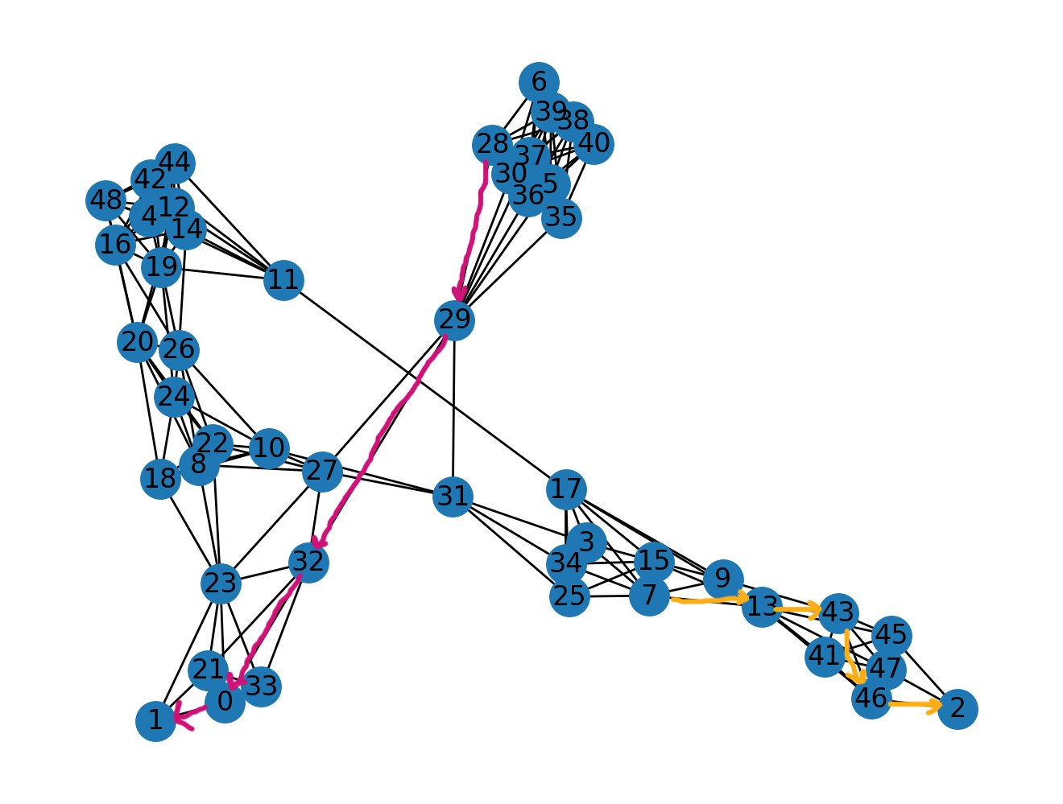

c) the performance metrics that are calculated for this scenario are these:

nodes PDR [100.0, 76.66666666666667, 73.33333333333333, 100.0, 100.0, 96.55172413793103, 68.96551724137932, 96.55172413793103, 100.0, 75.86206896551724, 100.0, 100.0, 100.0, 100.0, 100.0, 100.0, 100.0, 96.55172413793103, 100.0, 100.0, 100.0, 96.55172413793103, 100.0, 96.55172413793103, 96.55172413793103, 100.0, 96.55172413793103, 100.0, 86.20689655172413, 100.0, 96.55172413793103, 0, 96.55172413793103, 100.0, 96.55172413793103, 100.0, 100.0, 62.06896551724138, 68.96551724137932, 89.65517241379311, 96.55172413793103, 96.55172413793103, 100.0, 55.172413793103445, 100.0, 72.41379310344827, 82.75862068965517, 75.86206896551724, 100.0]

average PDR in the network [92.63649425287356]

average latency in each node [24.391034482758915, 29.198695652173697, 6.951818181818143, 0.4620689655173386, 33.576206896551405, 17.423571428571677, 3.259000000000424, 2320.5049999999997, 1.4896551724137241, 3.7027272727273672, 0.5417241379308476, 3.6927586206900367, 6.245517241379267, 15.167241379310576, 24.639310344827773, 5.71413793103457, 6.631379310344951, 11.230357142857267, 3.5134482758622685, 15.244482758620741, 13.784482758620847, 2.8232142857144464, 3.237241379310168, 9.444642857142858, 2.3603571428577164, 0.6155172413794562, 11.68107142857154, 0.46724137931024134, 2010.6144, 0.5975862068966354, 10.94785714285745, 0, 16.695714285714537, 3.553103448275939, 0.6985714285710368, 11.939655172413973, 1.639999999999653, 21.21666666666634, 5.136500000000251, 18.413846153845988, 17.3350000000002, 23.588571428571317, 18.92413793103453, 8.763749999999874, 14.934827586206737, 9.347619047619121, 6.216666666666981, 2.5622727272726915, 14.459655172414026]

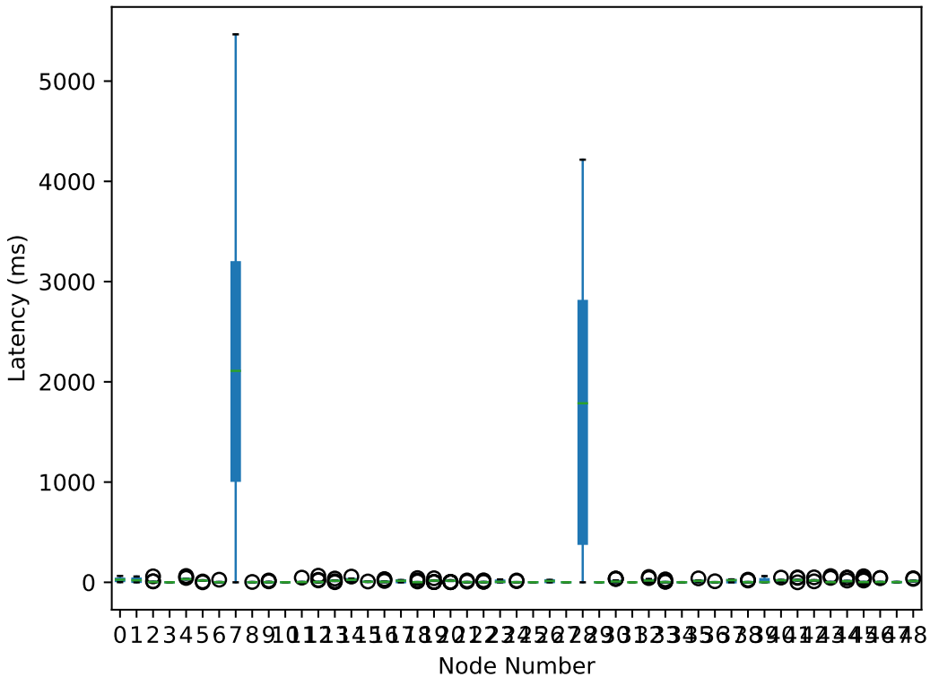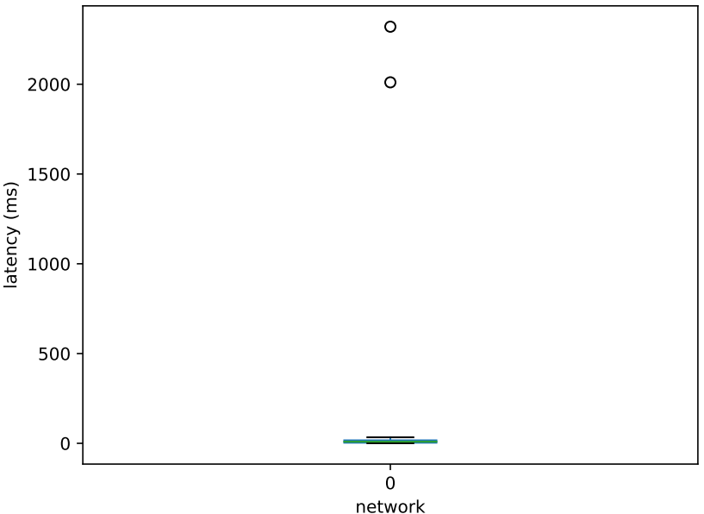

average burst packet loss in each node [[0, 0.30434782608695654, 0.36363636363636365, 0, 0, 0, 0.35, 0, 0, 0.22727272727272727, 0, 0, 0, 0, 0, 0, 0, 0, 0, 0, 0, 0.03571428571428571, 0, 0.03571428571428571, 0.03571428571428571, 0, 0.03571428571428571, 0, 0.04, 0, 0.03571428571428571, 0, 0.03571428571428571, 0, 0.03571428571428571, 0, 0, 0.5555555555555556, 0.45, 0.11538461538461539, 0.03571428571428571, 0.03571428571428571, 0, 0.8125, 0, 0.38095238095238093, 0.16666666666666666, 0.3181818181818182, 0]]

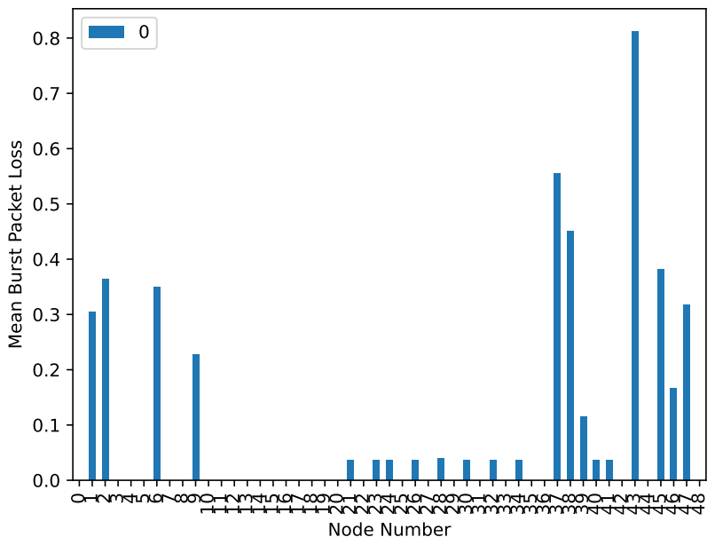

scanning energy in each node [1208.4910200029344, 141.5965199999626, 192.9458999999159, 1214.8711200029575, 1211.0263800029436, 1215.50496000296, 1226.0634000029984, 1213.6451400029532, 1204.0708200029183, 1213.1197200029512, 1202.9282400029142, 1206.5061000029273, 1208.4993600029345, 1212.9195600029504, 1208.5410600029347, 1213.1781000029514, 1212.1189200029476, 1210.4926200029417, 1213.6951800029533, 1206.2308800029261, 1209.0331200029364, 1210.0172400029398, 1203.7622400029172, 1203.3035400029155, 1208.2074600029334, 1213.2364800029516, 1209.0581400029366, 1203.0450000029145, 1215.3882000029594, 1206.7980000029283, 1214.8961400029577, 1250.107620003086, 1204.3126800029193, 1209.8921400029396, 1213.328220002952, 1216.072080002962, 1215.7134600029606, 1215.0379200029583, 1225.0209000029945, 1225.437900002996, 1224.7623600029935, 1219.383060002974, 1211.0013600029436, 1219.8000600029757, 1210.7511600029427, 1218.3655800029703, 1246.2879000030719, 1218.9910800029727, 1213.319880002952]

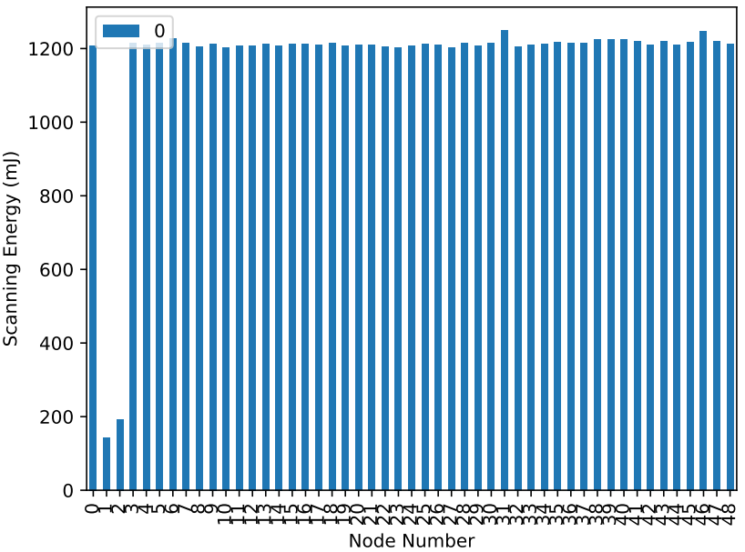

switching energy in each node [2.7142560000000713, 0.27340199999999937, 0.3030479999999991, 2.3420340000000572, 2.5462620000000653, 2.292624000000055, 1.62394200000003, 2.42767800000006, 2.9777760000000497, 2.4210900000000604, 3.076596000000035, 2.832840000000072, 2.7406080000000723, 2.4177960000000605, 2.7274320000000722, 2.41450200000006, 2.5297920000000644, 2.5890840000000668, 2.378268000000059, 2.855898000000068, 2.697786000000071, 2.6286120000000683, 2.997540000000047, 3.04365600000004, 2.7406080000000723, 2.378268000000059, 2.6582580000000693, 3.10953600000003, 2.2893300000000556, 2.8460160000000703, 2.2860360000000552, 0.023057999999999995, 2.964600000000052, 2.6286120000000683, 2.3749740000000585, 2.2695660000000544, 2.292624000000055, 2.2959180000000554, 1.6568820000000315, 1.6568820000000315, 1.6601760000000316, 1.9994580000000444, 2.539674000000065, 2.015928000000045, 2.5561440000000655, 2.068632000000047, 0.2964599999999991, 2.068632000000047, 2.4243840000000607]

transmitting energy in each node [19.050220799998943, 1.9188936000000056, 2.1269664000000073, 16.437751199999173, 17.871141599999046, 16.0909631999992, 11.397765599999609, 17.03885039999912, 20.899756799998784, 16.992611999999124, 21.593332799998723, 19.882511999998872, 19.23517439999893, 16.969492799999127, 19.142697599998936, 16.94637359999913, 17.75554559999906, 18.17169119999902, 16.692062399999152, 20.04434639999886, 18.934624799998954, 18.449121599999, 21.038471999998773, 21.362140799998745, 19.23517439999893, 16.692062399999152, 18.65719439999898, 21.824524799998706, 16.067843999999205, 19.974988799998865, 16.04472479999921, 0.16183440000000002, 20.80727999999879, 18.449121599999, 16.668943199999152, 15.929128799999216, 16.0909631999992, 16.1140823999992, 11.62895759999959, 11.62895759999959, 11.652076799999588, 14.03335439999938, 17.824903199999053, 14.14895039999937, 17.940499199999042, 14.51885759999934, 2.0807280000000064, 14.51885759999934, 17.01573119999912]

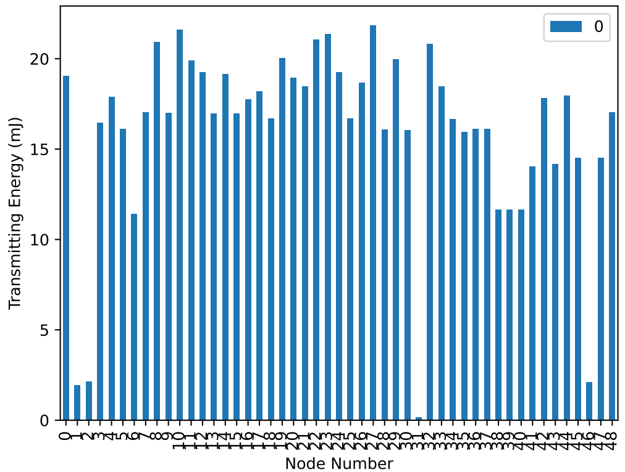

sleeping energy in each node [0.0, 1.1838, 1.1337, 0.0, 0.0, 0.0, 0.0, 0.0, 0.0, 0.0, 0.0, 0.0, 0.0, 0.0, 0.0, 0.0, 0.0, 0.0, 0.0, 0.0, 0.0, 0.0, 0.0, 0.0, 0.0, 0.0, 0.0, 0.0, 0.0, 0.0, 0.0, -0.0, 0.0, 0.0, 0.0, 0.0, 0.0, 0.0, 0.0, 0.0, 0.0, 0.0, 0.0, 0.0, 0.0, 0.0, -0.0, 0.0, 0.0]

total energy in each node [1230.2554968029333, 144.9726155999626, 196.5096143999159, 1233.6509052029567, 1231.4437836029426, 1233.8885472029592, 1239.0851076029978, 1233.1116684029523, 1227.948352802917, 1232.5334220029504, 1227.598168802913, 1229.221452002926, 1230.4751424029334, 1232.3068488029496, 1230.4111896029337, 1232.5389756029506, 1232.4042576029467, 1231.2533952029407, 1232.7655104029527, 1229.131124402925, 1230.6655308029356, 1231.0949736029388, 1227.7982520029161, 1227.7093368029143, 1230.1832424029324, 1232.306810402951, 1230.3735924029359, 1227.9790608029132, 1233.7453740029587, 1229.619004802927, 1233.2269008029568, 1250.292512403086, 1228.0845600029181, 1230.9698736029386, 1232.3721372029513, 1234.2707748029611, 1234.0970472029599, 1233.4479204029576, 1238.3067396029942, 1238.7237396029957, 1238.0746128029932, 1235.4158724029733, 1231.3659372029426, 1235.9649384029751, 1231.247803202942, 1234.9530696029697, 1248.6650880030718, 1235.578569602972, 1232.7599952029514]

network energy consumption (mJ) 58290.79884853869

**Conclusion**:

As the charts illustrate, we could see a huge difference between the first and current scenarios. When we have low-power nodes in our network it could have various impacts on our network.

For example, the total energy consumption decreased in comparison to the network without any low power node in it.

The other effect is on the Packet delivery ratio and latency. As a matter of fact, putting low-power and friend nodes in our network could change the behavior of packet delivery In our network for both random and grid topologies.